**Model Runs and Results**

For programming our project model in Python, we have considered 4x4 grid of play space for the agent. Which is as follows:

|  |  |  |  |
| --- | --- | --- | --- |
| L13 | L14  **DANGER** | L15 | L16  **2nd GOAL** |
| L11 | L10  **1st GOAL** | L11 | L12 |
| L5 | L6 | L7 | L8 |
| L1  C:\Users\Yogesh-PC\AppData\Local\Microsoft\Windows\INetCache\IE\N8E9KCBX\rocket_red[1].png | L2 | L3 | L4  **FINAL GOAL** |

Below are the output samples of our code in the environment shown in above table:

|  |
| --- |
| **OUTPUT 1 :**  C:\Users\Yogesh-PC\PycharmProjects\p1\venv\Scripts\python.exe F:/UIC/CogSci/ref/p1.py  --------------------- Welcome to The Great Galactic Escape -------------------  Agent Ready!!  -------------- RUN 1 -----------------  Next Goal: ['NextGoalLoc', 'L10']  Initial path memory []  Updated Next Goal to: ['NextGoalLoc', 'L16']  Updated path memory ['L2', 'L3', 'L2', 'L1', 'L2', 'L6', 'L7', 'L6', 'L2', 'L6', 'L10']  Agent Killed By The Alien Spaceship!! GAME OVER !!!  ['L10', ['C4', 'open', 1.0], 'L14']  In this run, Agent Travelled : ['L2', 'L3', 'L2', 'L1', 'L2', 'L6', 'L7', 'L6', 'L2', 'L6', 'L10', 'L14']  -------------- RUN 2 -----------------  Next Goal: ['NextGoalLoc', 'L10']  Initial path memory ['L2', 'L3', 'L2', 'L1', 'L2', 'L6', 'L7', 'L6', 'L2', 'L6', 'L10', 'L14']  Updated Next Goal to: ['NextGoalLoc', 'L16']  Updated path memory ['L2', 'L3', 'L2', 'L1', 'L2', 'L6', 'L7', 'L6', 'L2', 'L6', 'L10', 'L14', 'L5', 'L6', 'L5', 'L6', 'L10']  Updated Next Goal to: ['NextGoalLoc', 'L4']  Updated path memory ['L2', 'L3', 'L2', 'L1', 'L2', 'L6', 'L7', 'L6', 'L2', 'L6', 'L10', 'L14', 'L5', 'L6', 'L5', 'L6', 'L10', 'L9', 'L10', 'L6', 'L10', 'L11', 'L7', 'L11', 'L15', 'L16']  Mission Complete! Arrived at EARTH and **Agent Won Full Prize in 19 steps**  In this run, Agent Travelled : ['L5', 'L6', 'L5', 'L6', 'L10', 'L9', 'L10', 'L6', 'L10', 'L11', 'L7', 'L11', 'L15', 'L16', 'L15', 'L16', 'L12', 'L8', 'L4']  -------------- RUN 3 -----------------  Next Goal: ['NextGoalLoc', 'L10']  Initial path memory ['L2', 'L3', 'L2', 'L1', 'L2', 'L6', 'L7', 'L6', 'L2', 'L6', 'L10', 'L14', 'L5', 'L6', 'L5', 'L6', 'L10', 'L9', 'L10', 'L6', 'L10', 'L11', 'L7', 'L11', 'L15', 'L16', 'L15', 'L16', 'L12', 'L8', 'L4']  Updated Next Goal to: ['NextGoalLoc', 'L16']  Updated path memory ['L2', 'L3', 'L2', 'L1', 'L2', 'L6', 'L7', 'L6', 'L2', 'L6', 'L10', 'L14', 'L5', 'L6', 'L5', 'L6', 'L10', 'L9', 'L10', 'L6', 'L10', 'L11', 'L7', 'L11', 'L15', 'L16', 'L15', 'L16', 'L12', 'L8', 'L4', 'L2', 'L6', 'L10']  Updated Next Goal to: ['NextGoalLoc', 'L4']  Updated path memory ['L2', 'L3', 'L2', 'L1', 'L2', 'L6', 'L7', 'L6', 'L2', 'L6', 'L10', 'L14', 'L5', 'L6', 'L5', 'L6', 'L10', 'L9', 'L10', 'L6', 'L10', 'L11', 'L7', 'L11', 'L15', 'L16', 'L15', 'L16', 'L12', 'L8', 'L4', 'L2', 'L6', 'L10', 'L11', 'L10', 'L11', 'L15', 'L11', 'L15', 'L16']  Mission Complete! Arrived at EARTH and **Agent Won Full Prize in 17 steps**  In this run, Agent Travelled : ['L2', 'L6', 'L10', 'L11', 'L10', 'L11', 'L15', 'L11', 'L15', 'L16', 'L12', 'L11', 'L12', 'L16', 'L12', 'L8', 'L4']  -------------- Final Run -----------------  Next Goal: ['NextGoalLoc', 'L10']  Initial path memory ['L2', 'L3', 'L2', 'L1', 'L2', 'L6', 'L7', 'L6', 'L2', 'L6', 'L10', 'L14', 'L5', 'L6', 'L5', 'L6', 'L10', 'L9', 'L10', 'L6', 'L10', 'L11', 'L7', 'L11', 'L15', 'L16', 'L15', 'L16', 'L12', 'L8', 'L4', 'L2', 'L6', 'L10', 'L11', 'L10', 'L11', 'L15', 'L11', 'L15', 'L16', 'L12', 'L11', 'L12', 'L16', 'L12', 'L8', 'L4']  Updated Next Goal to: ['NextGoalLoc', 'L16']  Updated path memory ['L2', 'L3', 'L2', 'L1', 'L2', 'L6', 'L7', 'L6', 'L2', 'L6', 'L10', 'L14', 'L5', 'L6', 'L5', 'L6', 'L10', 'L9', 'L10', 'L6', 'L10', 'L11', 'L7', 'L11', 'L15', 'L16', 'L15', 'L16', 'L12', 'L8', 'L4', 'L2', 'L6', 'L10', 'L11', 'L10', 'L11', 'L15', 'L11', 'L15', 'L16', 'L12', 'L11', 'L12', 'L16', 'L12', 'L8', 'L4', 'L5', 'L6', 'L10']  Updated Next Goal to: ['NextGoalLoc', 'L4']  Updated path memory ['L2', 'L3', 'L2', 'L1', 'L2', 'L6', 'L7', 'L6', 'L2', 'L6', 'L10', 'L14', 'L5', 'L6', 'L5', 'L6', 'L10', 'L9', 'L10', 'L6', 'L10', 'L11', 'L7', 'L11', 'L15', 'L16', 'L15', 'L16', 'L12', 'L8', 'L4', 'L2', 'L6', 'L10', 'L11', 'L10', 'L11', 'L15', 'L11', 'L15', 'L16', 'L12', 'L11', 'L12', 'L16', 'L12', 'L8', 'L4', 'L5', 'L6', 'L10', 'L11', 'L12', 'L11', 'L12', 'L16']  Mission Complete! Arrived at EARTH and **Agent Won Full Prize in 13 steps**  In this run, Agent Travelled : ['L5', 'L6', 'L10', 'L11', 'L12', 'L11', 'L12', 'L16', 'L12', 'L8', 'L7', 'L8', 'L4']  Process finished with exit code 0 |

|  |
| --- |
| **OUTPUT 2:**  C:\Users\Yogesh-PC\PycharmProjects\p1\venv\Scripts\python.exe F:/UIC/CogSci/ref/p1.py  --------------------- Welcome to The Great Galactic Escape -------------------  Agent Ready!!  -------------- RUN 1 -----------------  Next Goal: ['NextGoalLoc', 'L10']  Initial path memory []  Updated Next Goal to: ['NextGoalLoc', 'L16']  Updated path memory ['L2', 'L1', 'L2', 'L6', 'L7', 'L6', 'L10']  Updated Next Goal to: ['NextGoalLoc', 'L4']  Updated path memory ['L2', 'L1', 'L2', 'L6', 'L7', 'L6', 'L10', 'L11', 'L7', 'L11', 'L10', 'L11', 'L12', 'L16']  Mission Complete! Arrived at EARTH and **Agent Won Full Prize in 23 steps**  In this run, Agent Travelled : ['L2', 'L1', 'L2', 'L6', 'L7', 'L6', 'L10', 'L11', 'L7', 'L11', 'L10', 'L11', 'L12', 'L16', 'L12', 'L11', 'L12', 'L16', 'L12', 'L8', 'L12', 'L8', 'L4']  -------------- RUN 2 -----------------  Next Goal: ['NextGoalLoc', 'L10']  Initial path memory ['L2', 'L1', 'L2', 'L6', 'L7', 'L6', 'L10', 'L11', 'L7', 'L11', 'L10', 'L11', 'L12', 'L16', 'L12', 'L11', 'L12', 'L16', 'L12', 'L8', 'L12', 'L8', 'L4']  Updated Next Goal to: ['NextGoalLoc', 'L16']  Updated path memory ['L2', 'L1', 'L2', 'L6', 'L7', 'L6', 'L10', 'L11', 'L7', 'L11', 'L10', 'L11', 'L12', 'L16', 'L12', 'L11', 'L12', 'L16', 'L12', 'L8', 'L12', 'L8', 'L4', 'L5', 'L1', 'L5', 'L9', 'L5', 'L9', 'L13', 'L9', 'L10']  Agent Killed By The Alien Spaceship!! GAME OVER !!!  ['L10', ['C4', 'open', 1.0], 'L14']  In this run, Agent Travelled : ['L5', 'L1', 'L5', 'L9', 'L5', 'L9', 'L13', 'L9', 'L10', 'L14']  -------------- RUN 3 -----------------  Next Goal: ['NextGoalLoc', 'L10']  Initial path memory ['L2', 'L1', 'L2', 'L6', 'L7', 'L6', 'L10', 'L11', 'L7', 'L11', 'L10', 'L11', 'L12', 'L16', 'L12', 'L11', 'L12', 'L16', 'L12', 'L8', 'L12', 'L8', 'L4', 'L5', 'L1', 'L5', 'L9', 'L5', 'L9', 'L13', 'L9', 'L10', 'L14']  Updated Next Goal to: ['NextGoalLoc', 'L16']  Updated path memory ['L2', 'L1', 'L2', 'L6', 'L7', 'L6', 'L10', 'L11', 'L7', 'L11', 'L10', 'L11', 'L12', 'L16', 'L12', 'L11', 'L12', 'L16', 'L12', 'L8', 'L12', 'L8', 'L4', 'L5', 'L1', 'L5', 'L9', 'L5', 'L9', 'L13', 'L9', 'L10', 'L14', 'L2', 'L6', 'L2', 'L6', 'L10']  Updated Next Goal to: ['NextGoalLoc', 'L4']  Updated path memory ['L2', 'L1', 'L2', 'L6', 'L7', 'L6', 'L10', 'L11', 'L7', 'L11', 'L10', 'L11', 'L12', 'L16', 'L12', 'L11', 'L12', 'L16', 'L12', 'L8', 'L12', 'L8', 'L4', 'L5', 'L1', 'L5', 'L9', 'L5', 'L9', 'L13', 'L9', 'L10', 'L14', 'L2', 'L6', 'L2', 'L6', 'L10', 'L9', 'L10', 'L6', 'L10', 'L11', 'L12', 'L8', 'L12', 'L11', 'L12', 'L16']  Mission Complete! Arrived at EARTH and **Agent Won Full Prize in 23 steps**  In this run, Agent Travelled : ['L2', 'L6', 'L2', 'L6', 'L10', 'L9', 'L10', 'L6', 'L10', 'L11', 'L12', 'L8', 'L12', 'L11', 'L12', 'L16', 'L15', 'L16', 'L12', 'L8', 'L7', 'L8', 'L4']  -------------- Final Run -----------------  Next Goal: ['NextGoalLoc', 'L10']  Initial path memory ['L2', 'L1', 'L2', 'L6', 'L7', 'L6', 'L10', 'L11', 'L7', 'L11', 'L10', 'L11', 'L12', 'L16', 'L12', 'L11', 'L12', 'L16', 'L12', 'L8', 'L12', 'L8', 'L4', 'L5', 'L1', 'L5', 'L9', 'L5', 'L9', 'L13', 'L9', 'L10', 'L14', 'L2', 'L6', 'L2', 'L6', 'L10', 'L9', 'L10', 'L6', 'L10', 'L11', 'L12', 'L8', 'L12', 'L11', 'L12', 'L16', 'L15', 'L16', 'L12', 'L8', 'L7', 'L8', 'L4']  Updated Next Goal to: ['NextGoalLoc', 'L16']  Updated path memory ['L2', 'L1', 'L2', 'L6', 'L7', 'L6', 'L10', 'L11', 'L7', 'L11', 'L10', 'L11', 'L12', 'L16', 'L12', 'L11', 'L12', 'L16', 'L12', 'L8', 'L12', 'L8', 'L4', 'L5', 'L1', 'L5', 'L9', 'L5', 'L9', 'L13', 'L9', 'L10', 'L14', 'L2', 'L6', 'L2', 'L6', 'L10', 'L9', 'L10', 'L6', 'L10', 'L11', 'L12', 'L8', 'L12', 'L11', 'L12', 'L16', 'L15', 'L16', 'L12', 'L8', 'L7', 'L8', 'L4', 'L5', 'L6', 'L5', 'L6', 'L10']  Updated Next Goal to: ['NextGoalLoc', 'L4']  Updated path memory ['L2', 'L1', 'L2', 'L6', 'L7', 'L6', 'L10', 'L11', 'L7', 'L11', 'L10', 'L11', 'L12', 'L16', 'L12', 'L11', 'L12', 'L16', 'L12', 'L8', 'L12', 'L8', 'L4', 'L5', 'L1', 'L5', 'L9', 'L5', 'L9', 'L13', 'L9', 'L10', 'L14', 'L2', 'L6', 'L2', 'L6', 'L10', 'L9', 'L10', 'L6', 'L10', 'L11', 'L12', 'L8', 'L12', 'L11', 'L12', 'L16', 'L15', 'L16', 'L12', 'L8', 'L7', 'L8', 'L4', 'L5', 'L6', 'L5', 'L6', 'L10', 'L11', 'L12', 'L16']  Mission Complete! Arrived at EARTH and **Agent Won Full Prize in 11 steps**  In this run, Agent Travelled : ['L5', 'L6', 'L5', 'L6', 'L10', 'L11', 'L12', 'L16', 'L12', 'L8', 'L4']  Process finished with exit code 0 |

The runs of the model are documented using the following graphs;

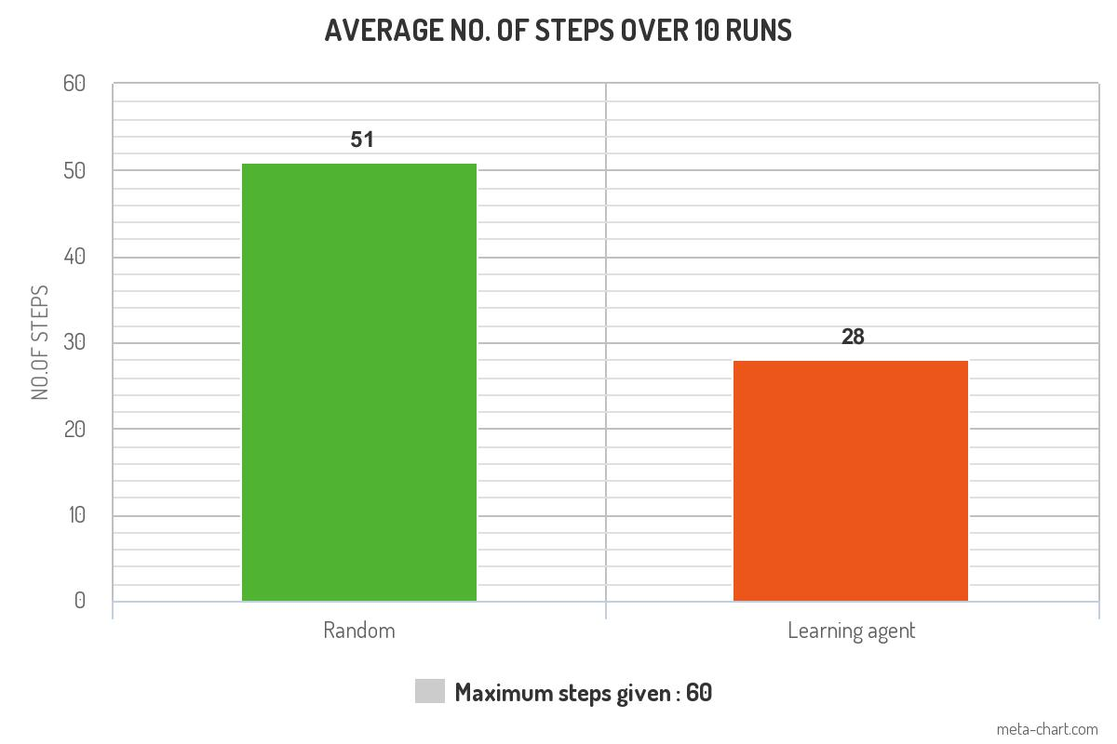

Graph 1

The model was run for 10 runs and the average number of steps were calculated for two approaches Random and Learning agent. Since, in the Random approach, the agent runs around in loops and takes more number of steps to reach the goal. In the Learning agent approach, the agent learns and thus takes less number of steps comparatively.

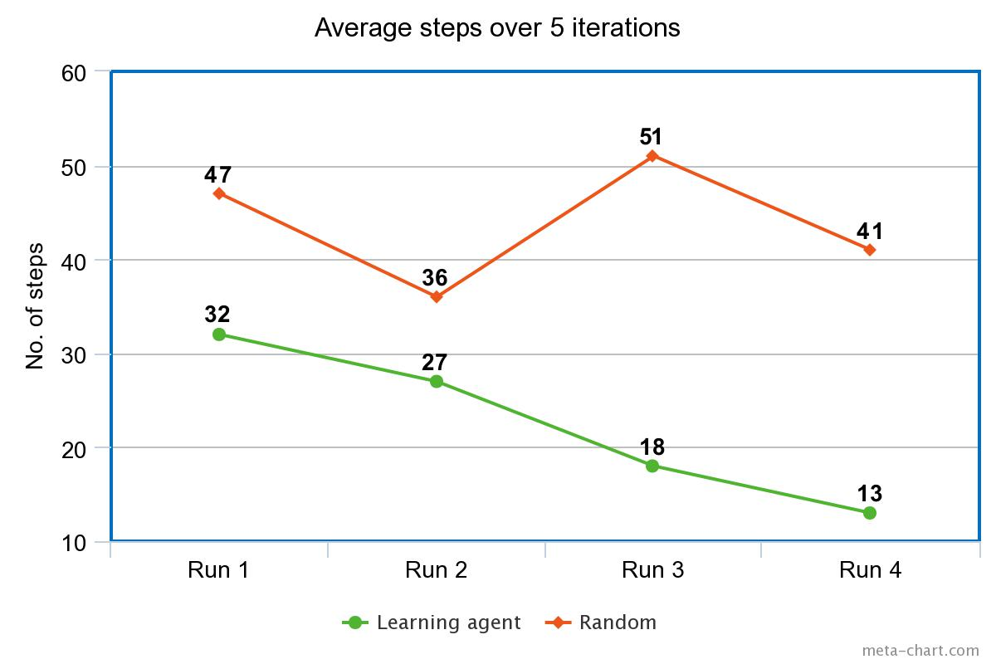

Graph 2

The Graph 2 depicts 4 runs that on the model in the two different approaches. In the Random approach, the agent does not learn and therefore the number of steps are arbitrary. However, in the Learning agent approach, the agent learns from its previous actions. Thus, the number of steps taken by the agent reduces at every run over time.